Project proposal for the development and validation of a DIY profiling float for salinity estimation– draft 1

Caleb Flaim1

[cflaim@uw.edu](mailto:cflaim@uw.edu)

1University of Washington, School of Oceanography

30 October 2023

**Key words:** AUV, DIY, open-source, halocline, mixing

**Project summary**

**Introduction**

**Proposed research**

**Proposed timeline and budget**

**Timeline**

This project will occur in three main stages: the float development, data analysis, and manuscript writing stages (see <https://github.com/cflaim1123/openFloat/blob/main/proposal/timelines/flaimThesisTimelineFull.pdf> for the full Gannt chart project timeline). The float development stage is to occur from 27 September 2023 to 13 December 2023, the duration of the autumn offering of Ocean 443 (Table 1). This stage begins with the building and programming of the float’s electrical systems that do not pertain to the buoyancy engine. After the float’s data collection electronics are operable, the float will be deployed in the main basin of Puget Sound, WA near Shilshole Bay Marina (see FIGURE #) alongside a seaglider for an initial validation of the system’s data collection and water proofness. Once the initial test deployment is finished, the design and build of the buoyancy engine will take place. The buoyancy engine will then be integrated with the float’s existing electrical systems and programmed to change volume given certain pressure, humidity, or acceleration signals. Finally, the float will be deployed in Colvos Passage, WA (see FIGURE #) alongside a seaglider for data collection and comparison. The following two stage will occur during the winter 2024 academic quarter and largely follow the timeline of the Ocean 444 course.

**Budget**

This project aims to build a DIY profiling float in under 500 USD (see <https://github.com/cflaim1123/openFloat/blob/main/proposal/budget/openFloatBudget.pdf> for the full budget). Funding for this project will come from the University of Washington Ocean Technology Center’s project budget. Table 2 details the overall expenditure for the project, as if none of the parts had already been purchased in the past. The electronics are common and easily-obtainable Arduino/Adafruit/Digikey or general circuitry products that are likely to be found in most electronics labs. Alternate versions of the electronics can be substituted, but are not documented in this project budget’s. The electrical-sensing category is the largest expense for the openFloat project, followed by Mechanical, Electrical-control, and Electrical-general categories.

**References**

**Figure captions**

**Figure 1:**

Panel a) shows the deployment location and likely track of seaglider 175 near Shilshole Bay, WA. Manual casts of the DIY float tethered to a line will be done at every seaglider dive sight to collect profile data. Panel b) shows the deployment location and likely track of seaglider 195 in Colvos Passage on the West side of Vashon Island. The DIY float will be deployed alongside the seaglider and allowed to drift down the passage while making continuous profiles. Red stars indicate possible seaglider and float dive sights or pickup locations. White lines represent the likely path of the seaglider or float once deployed. The red star circumscribed by a black circle indicates likely deployment locations. Actual deployment locations will vary depending on local boat traffic and tidal patterns.

**Tables**

**Table 1: Project timeline**

|  |  |  |  |
| --- | --- | --- | --- |
| **Project stage** | **Subsection** | **Start date** | **End date** |
| Float development | Concept development | 9/25/2023 | 10/04/2024 |
| Find and order parts | 9/25/2023 | 10/10/2023 |
| Background research | 10/02/2023 | 10/29/2023 |
| Electronics design | 10/09/2023 | 10/21/2023 |
| Electronics build | 10/20/2023 | 11/01/2023 |
| General programming | 10/30/2023 | 11/08/2023 |
| Float testing and deployment without profiling capability near Shilshole | 11/06/2023 | 11/10/2023 |
| Buoyancy engine build | 10/23/2023 | 11/03/2023 |
| Buoyancy engine build | 11/04/2023 | 11/20/2023 |
| Float assembly | 11/20/2023 | 11/26/2023 |
| Final float testing and deployment in Colvos Passage. | 11/27/2023 | 12/05/2023 |
| Data analysis | Produce desired plots to compare float data to seaglider data | 1/03/2024 | 1/11/2024 |
| Produce salinity transects of Colvos Passage | 1/11/2024 | 1/15/2024 |
| Produce engineering plots to asses float’s performance | 1/12/2024 | 1/16/2024 |
| Paper writing | Follow Ocean 444 assignment deadlines | 1/03/2024 | 3/12/2024 |

**Table 2: Project budget**

|  |  |  |  |  |
| --- | --- | --- | --- | --- |
| **Category** | **Item** | **#** | **Price per** | **Total price** |
| Electrical - general | perfboard (pack of 50) | 7 | $0.50 | $3.50 |
| Misc wires | NA | NA | $15.00 |
| Male header pins | NA | NA | $5.00 |
| Female header pins | NA | NA | $5.00 |
| Solder | NA | NA | $10.00 |
| Resistors | NA | NA | $0.10 |
| Misc GPS radio wires | NA | NA | $15.00 |
| Electrical - control | ESP32 feather huzzah v2 | 2 | $19.95 | $39.90 |
| BLDC motor | 1 | $30.00 | $30.00 |
| 5V, 5A voltage step-down regulator | 1 | $32.95 | $32.95 |
| custom battery pack | 1 | $15.00 | $15.00 |
| |  | | --- | | Electrical - sensing | |  | |  | |  | |  | |  | |  | |  | |  | |  | |  | | analog pressure sensor | 1 | $20.00 | $20.00 |
| Thermistor | 1 | $2.00 | $2.00 |
| adafruit data logger feather wing | 1 | $8.95 | $8.95 |
| digital temperature sensor (pack of 5) | 1 | $10.00 | $10.00 |
| BMP180 pressure sensor | 1 | $9.95 | $9.95 |
| DHT22 humidity sensor | 1 | $9.95 | $9.95 |
| TSL2591 lux sensor | 1 | $6.95 | $6.95 |
| Adafruit 9-DOF absolute orientation IMU - BN055 | 1 | $35.00 | $35.00 |
| Adafruit ultiamte GPS | 2 | $30.00 | $60.00 |
| 915 mHz LoRa radio module | 2 | $20.00 | $40.00 |
| Precision current meter | 1 | $10.00 | $10.00 |
| GPS antenna | 1 | $20.00 | $20.00 |
| Radio antenna | 2 | $10.00 | $20.00 |
| |  | | --- | | Mechanical | |  | |  | | Low-pitch, high-precision ACME lead screw | 1 | $15.00 | $15.00 |
| Misc O-ring | NA | NA | $10.00 |
| Misc PVC pipe for piston | 1 | $10.00 | $10.00 |
| 4" PVC pipe | 1 | $20.00 | $20.00 |
| 4" PVC endcaps | 2 | $10.00 | $20.00 |
| metal cable glands | 5 | $10.00 | $50.00 |
| Epoxy | 2 | $10.00 | $20.00 |
|  | | | Total: | $529.25 |

**Figures**

**Figure 1**

a)

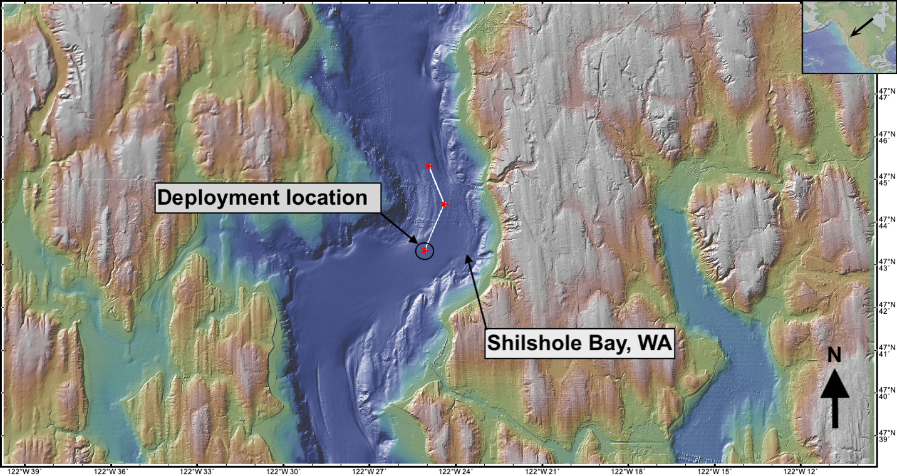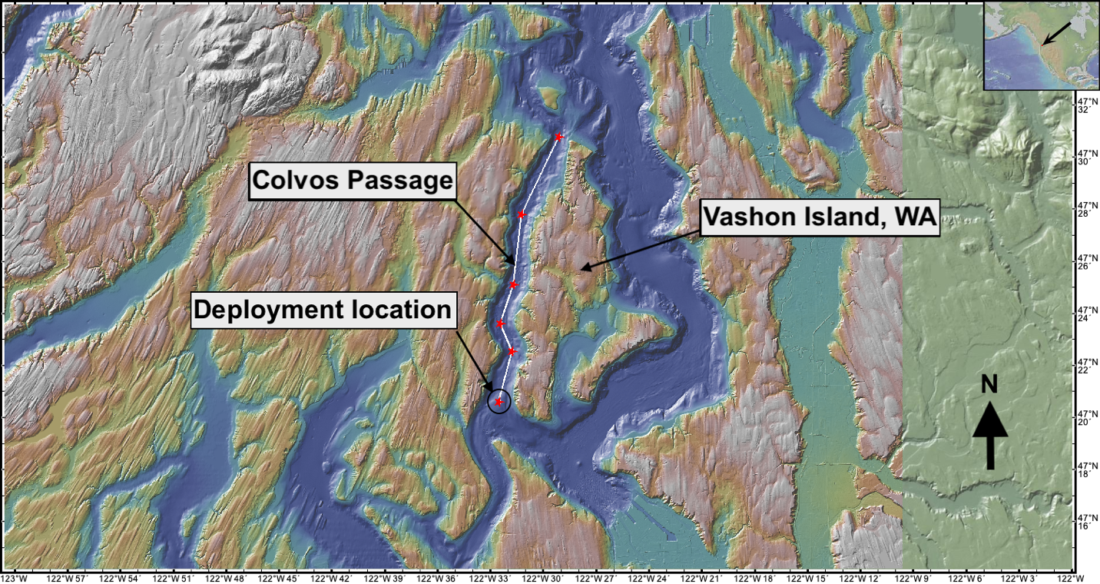

b)